**Fruit Disease identifICATION  
USING IMAGE PROCESSING**

**Team - 01**

* SC/2019/11150 V.M. Sooriyaarchchi
* SC/2019/11144 G.D.A.M. Asanka Madhushan
* SC/2019/11117 R.P.M.L. Vijayathunga
* SC/2019/11132 W.K.D.H. Hashan Piyumal
* SC/2019/11126 W.A.I.M.Weerasinghe (Leader)

**Introduction**

Nowadays, Agricultural processes are infused with modern technology to get better crops and profits as much as possible, but still, there are some areas in those processes which are in need of further development and research, One of them is the **differentiation between healthy fruits and unhealthy fruits**, That process is done manually by farmers in almost every situation throughout Sri Lanka, and the identification of those defective fruits and normal healthy fruits based on their quality in the food industry is a very important task in the food processing pipeline.

But this process can be automated to reduce the human effort and the time it consumes, and adaptation of this technique is a major development in agricultural automation. This technique can also be utilized with a fruit sorting machine in order to further reduce human effort, greatly reduce time consumed and minimize human error. Another benefit of this is that it greatly increases efficiency. Even a single farmer can adopt this method and benefit from it with a minimum cost.

**Problem Definition**

Most of the farmers manually separate healthy fruits from defective ones, doing this task manually leads to many problems, such as,

• Time consuming  
• Waste of human effort  
• At least one person is needed  
• Human error

All of these above-mentioned issues can be eliminated easily by using an automated sorting system along with having some other benefits also, And one of the main components of this system is the determination of the status of the fruits using image processing methods. By utilizing this method we can,

• Reduce time consumed  
• Increased efficiency  
• No human interaction is needed.  
• No human error  
• Cost-efficient

Our aim is to address above mentioned issues and provide an efficient, reliable and user-friendly solution.

**Proposed Solution**

In this project, we aim to use several image processing techniques to implement this technology.  
Some of them are,

• Image resizing

• Image restoration  
• Image Grey scaling  
• Image Binarization  
• Image segmentation  
• Trace boundaries of the affected areas

Our goal is to provide a **user-friendly**, **easy-to-learn** application built upon the above-mentioned techniques abstractly. So the end-user does not have to worry about those underlying methods, and they can implement the application easily to their work process.

**Example Case**

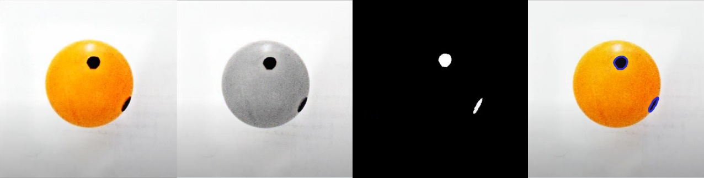

Above image shows an example of a case where input image of the fruit is affected by a disease, and in there intermediate image results are shown.

Final result will be a visual output of either “Healthy” or “Unhealthy”.